**Practical No. 5**

Aim: Upgrade the VMware ESXi server 6.7 to 7.0 using simple installation

Go to the VMware website labs.hol.vmware/hol/catalog

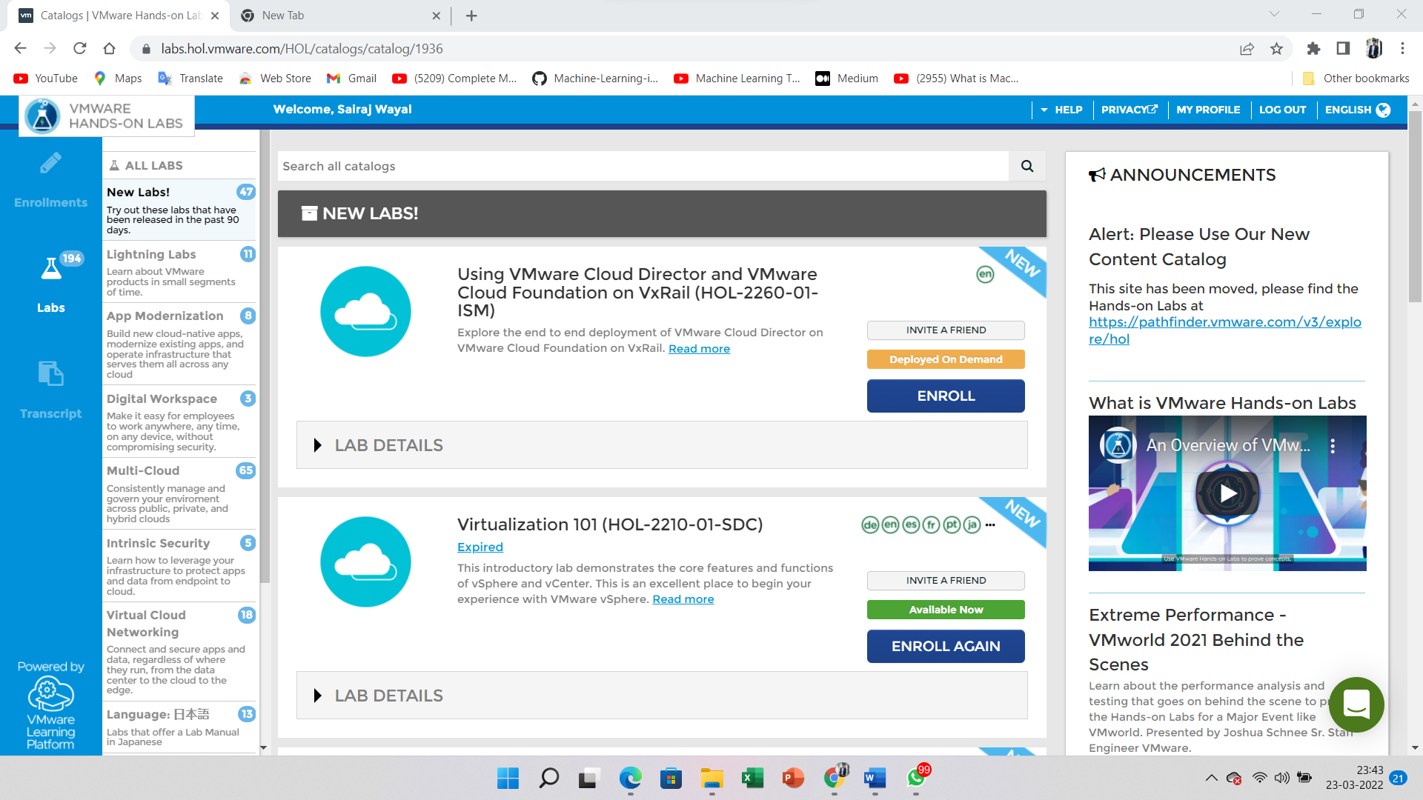

Search the 2211 on the search panel

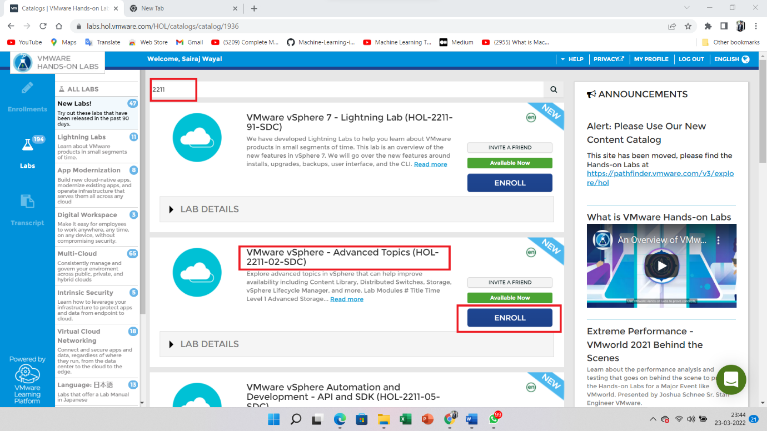

Start the lab of vSphere Advanced Topic (2211-02-SDC)

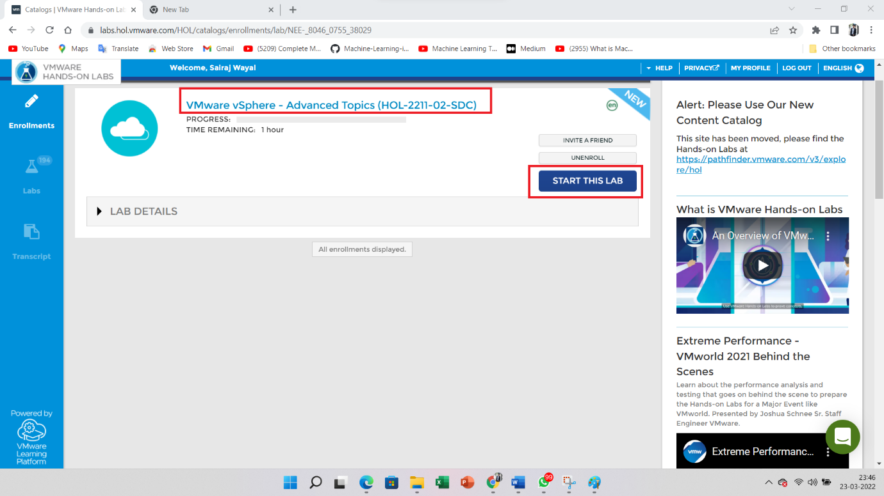

Open the Chrome Browser

Select the **vcsa-01a Web Client**

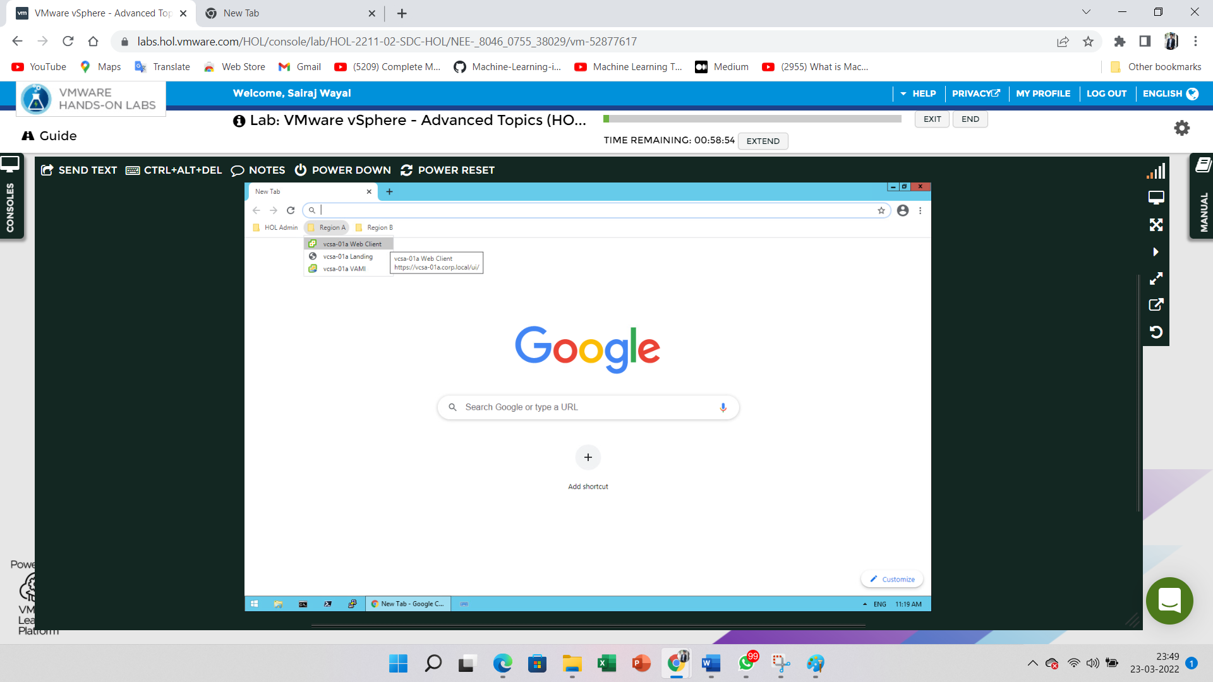

Go to the **RegionA01-COMP01** and Select the **Baseline** option inside the **Update** Tab

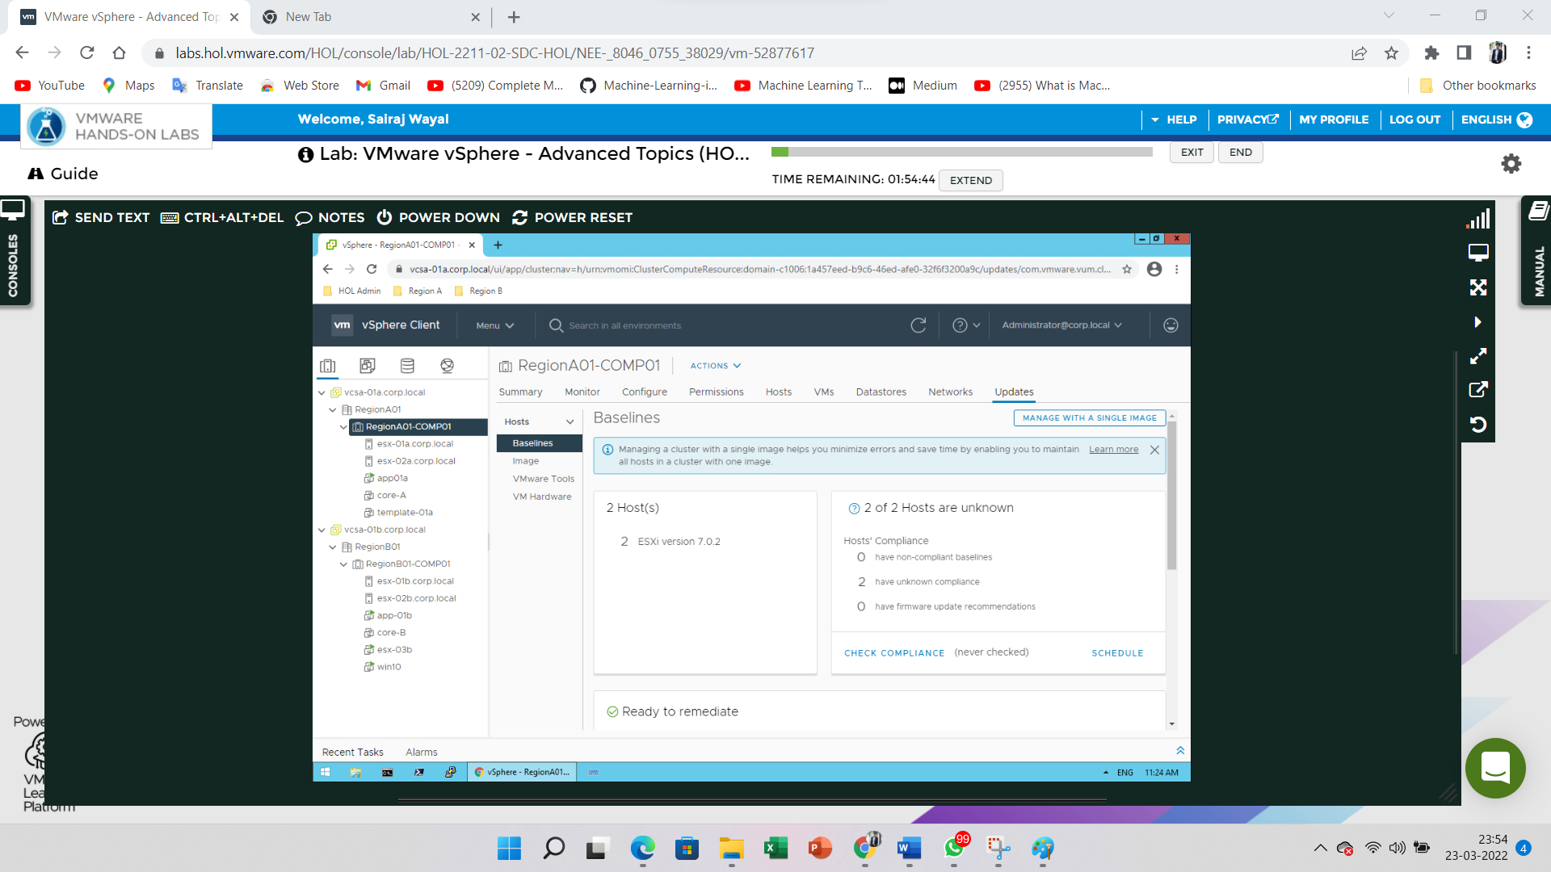

Go to **Menu** and click on the **Lifecycle Manager**

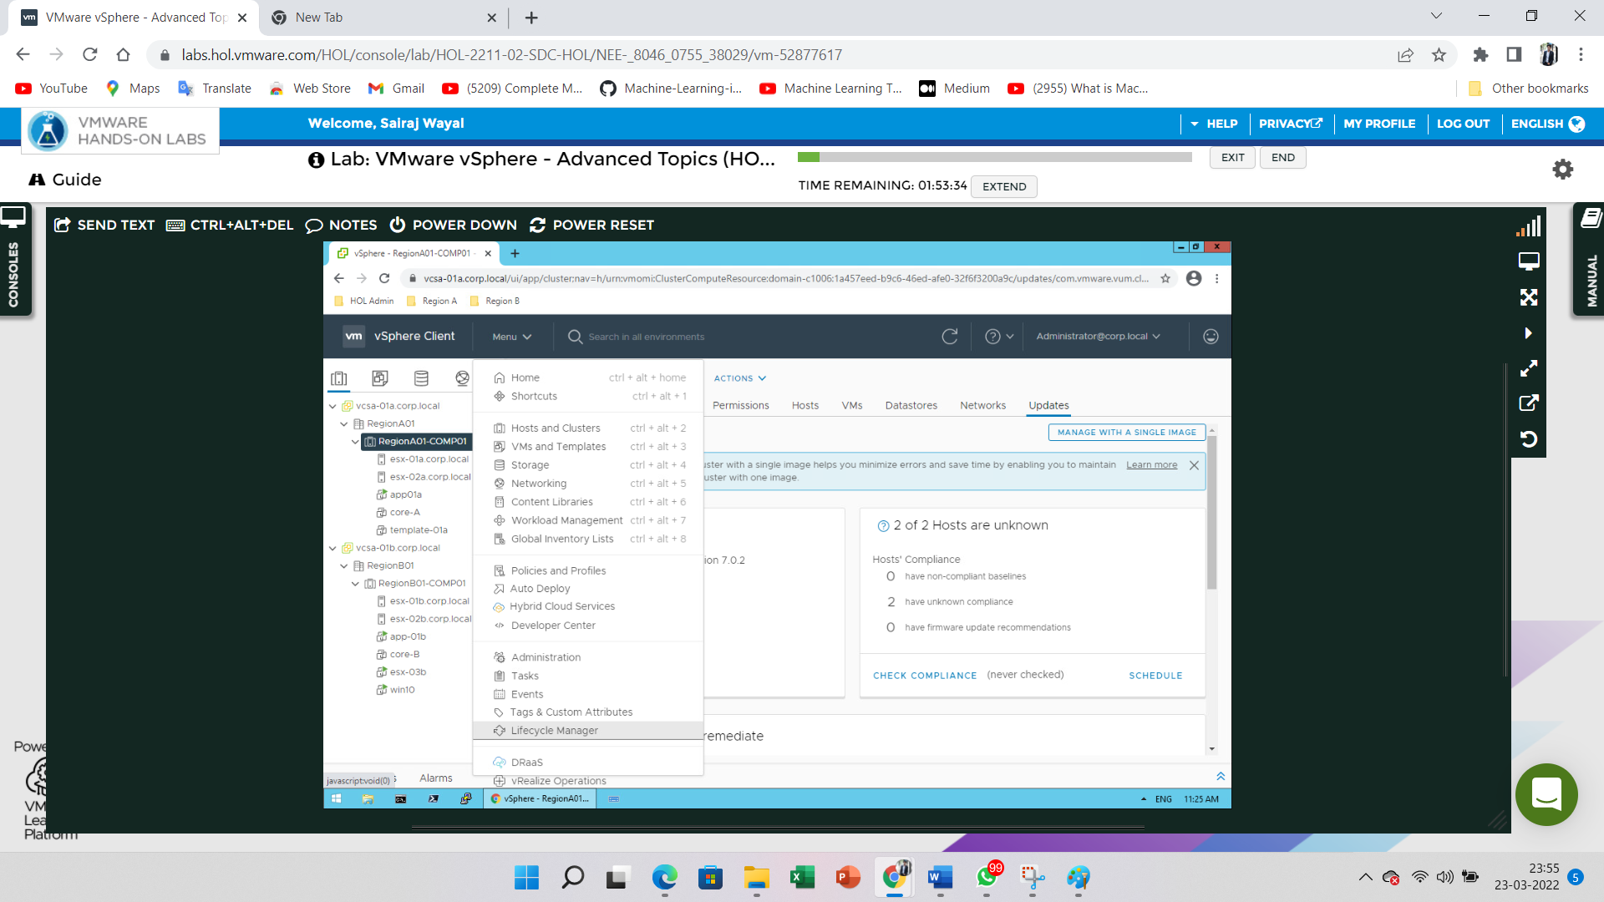

Click on the **Update** Tab and filter the Name i.e. esxi 7.0

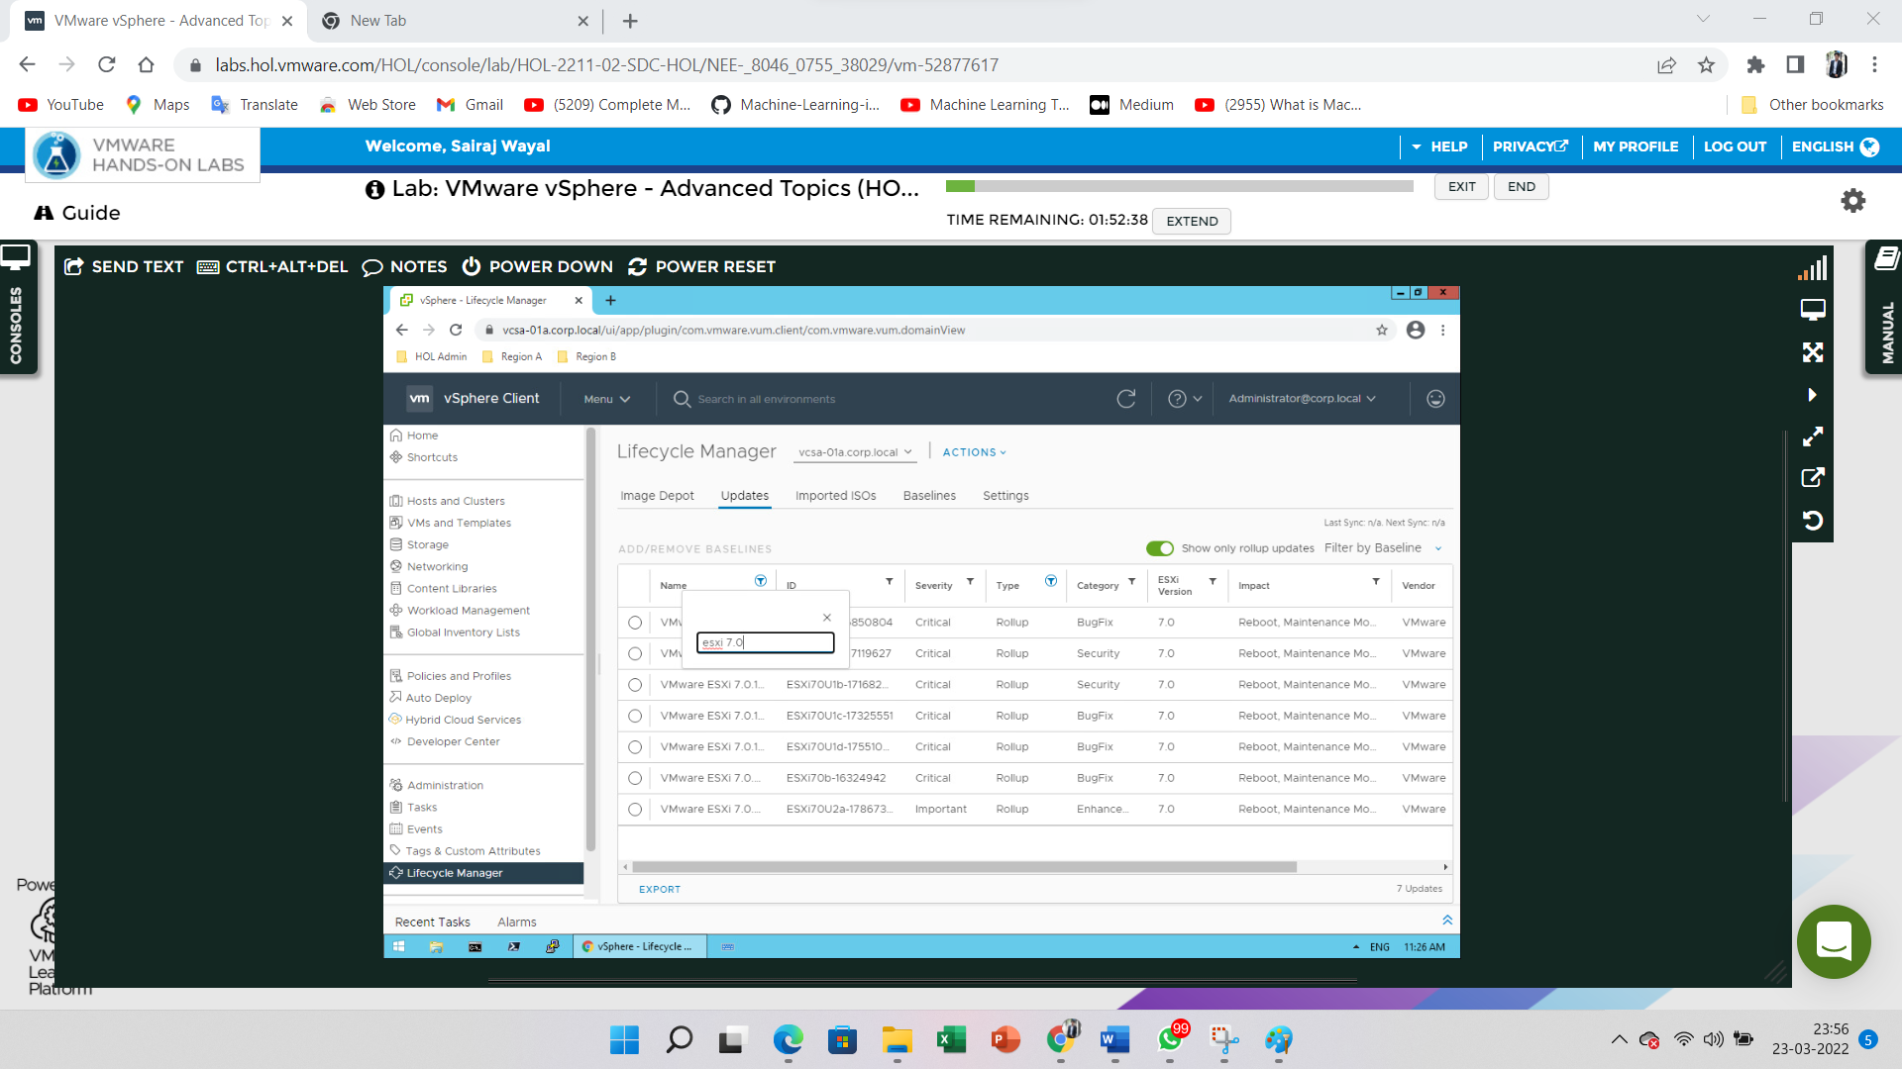

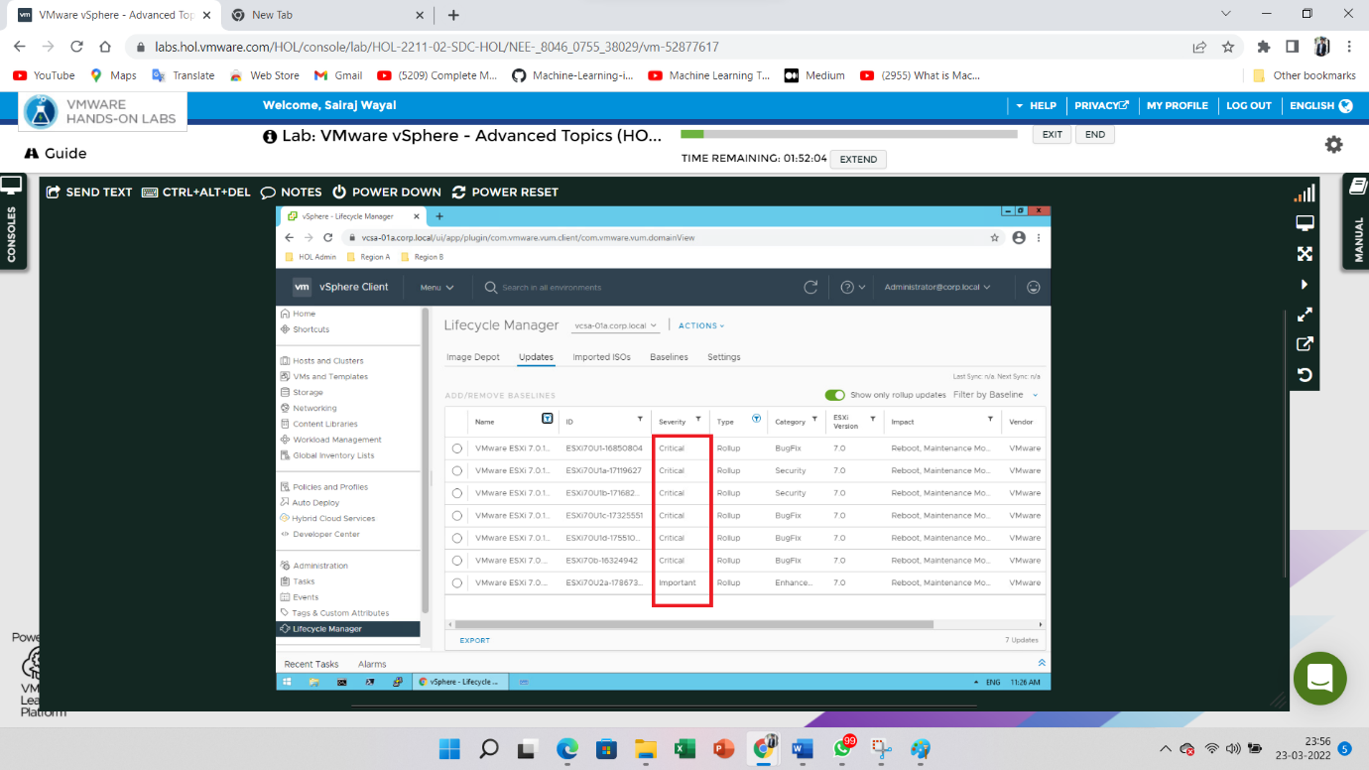

Go to the **Imported ISOs** **Tab** and Click on the **Import ISO** button

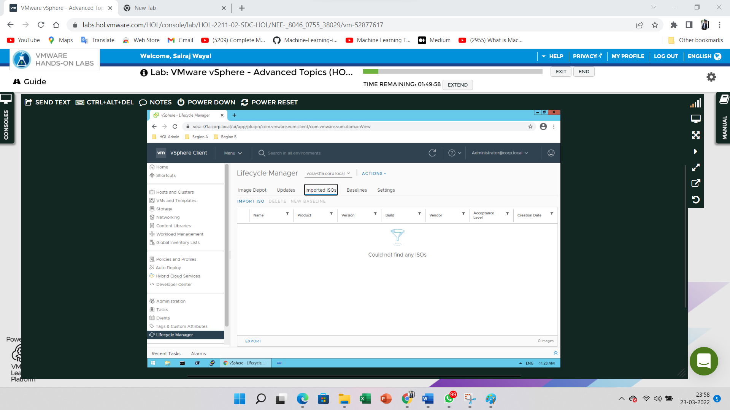

Click on the **Browse** button and browse the ISO file of VMvisor-installer respected path mention into the image and open it. After select the iso file then click on the **Import** button

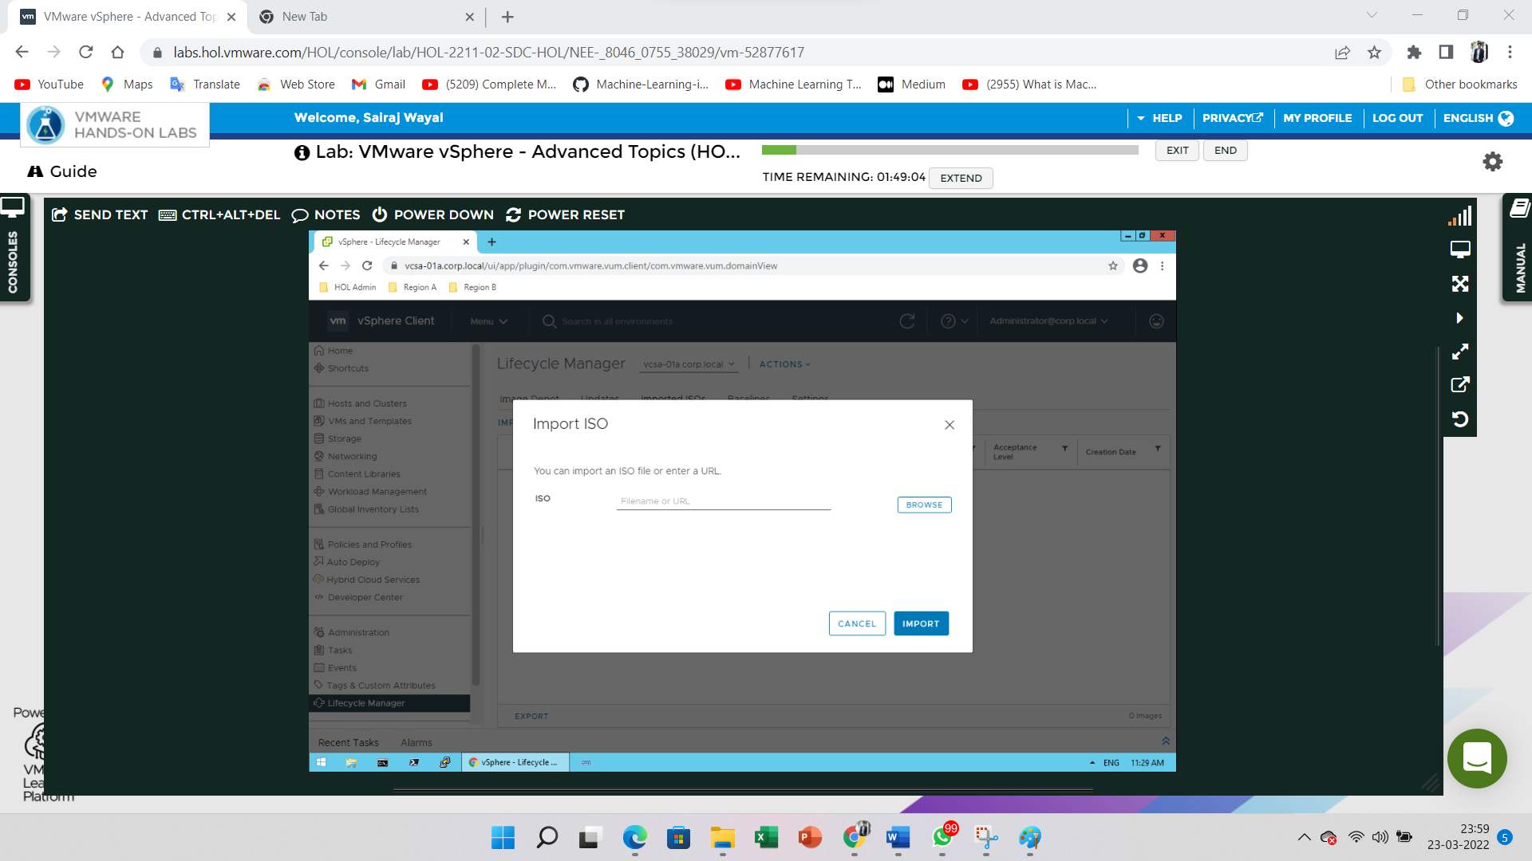

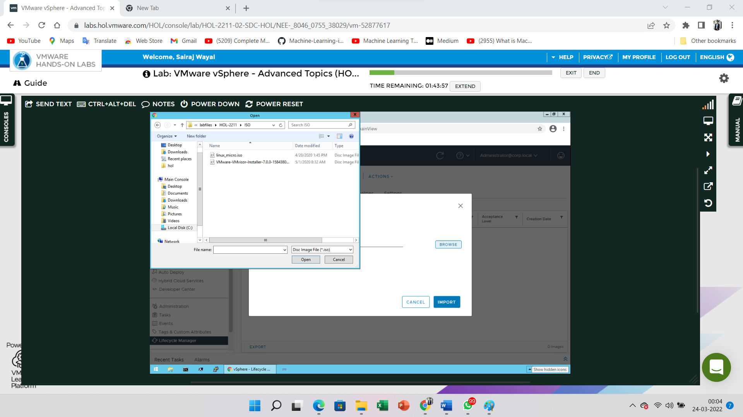

Wait few seconds for uploading the iso file

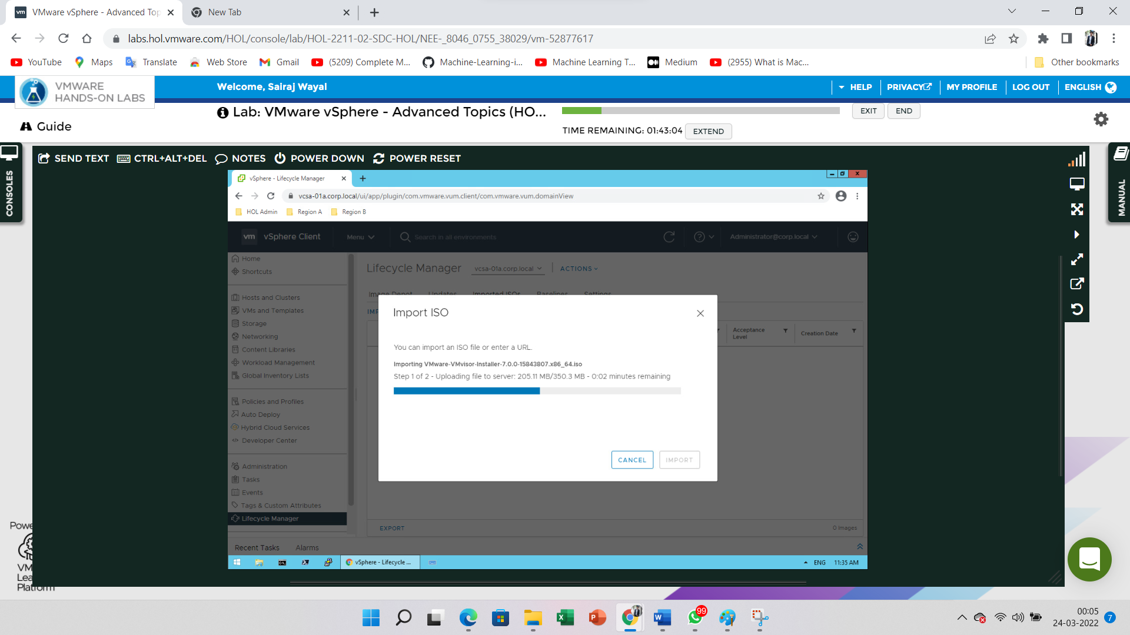

Go to an **Imported ISOs** Tab then view the uploaded iso file present

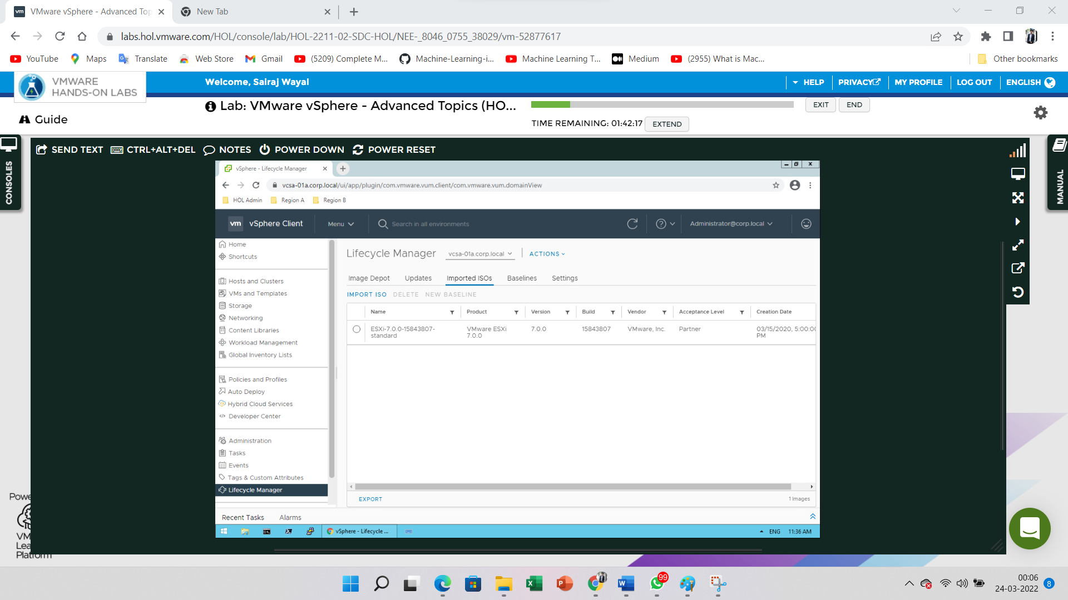

Select on the particular iso file mention on the image and Click on the **New Baseline**

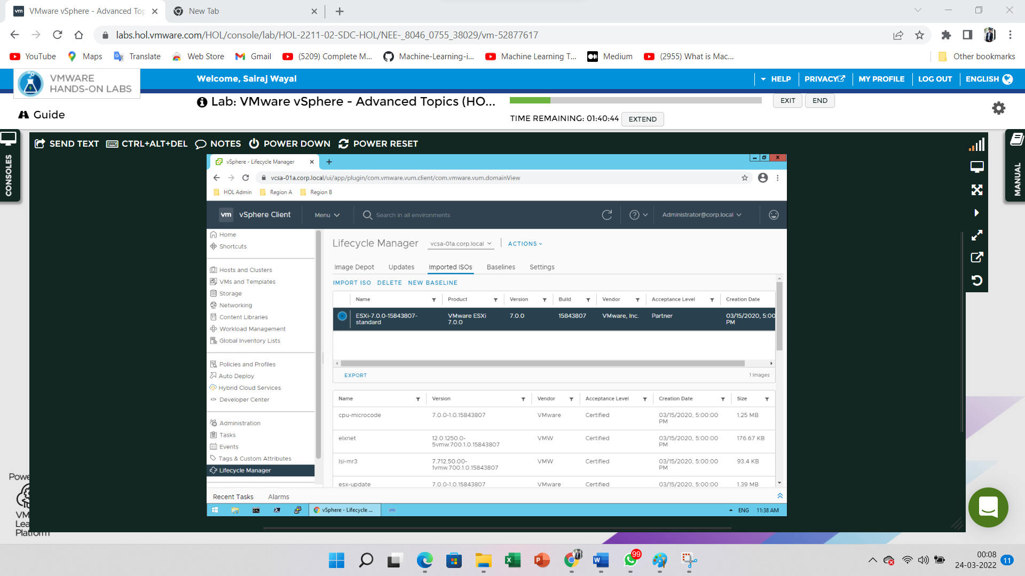

Enter the required field to fill it then click on the **Next** button

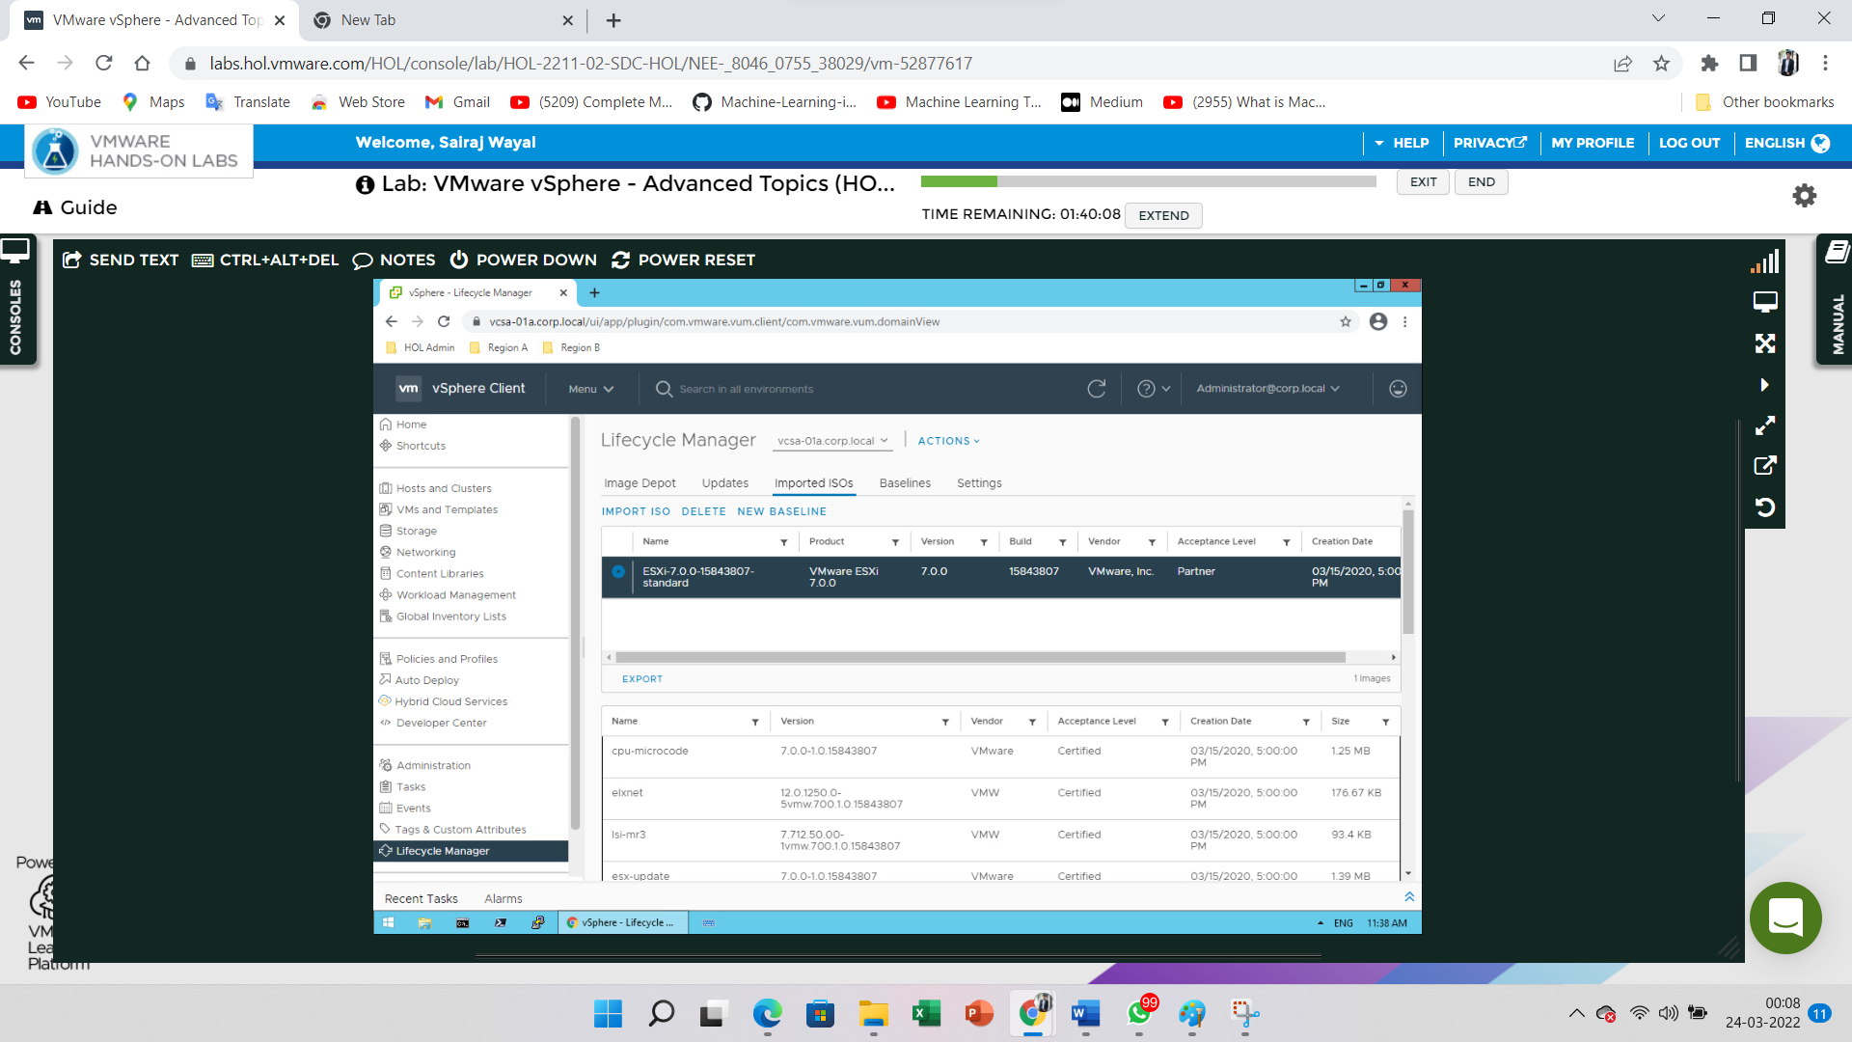

Enter the required field to fill it then click on the **Next** button

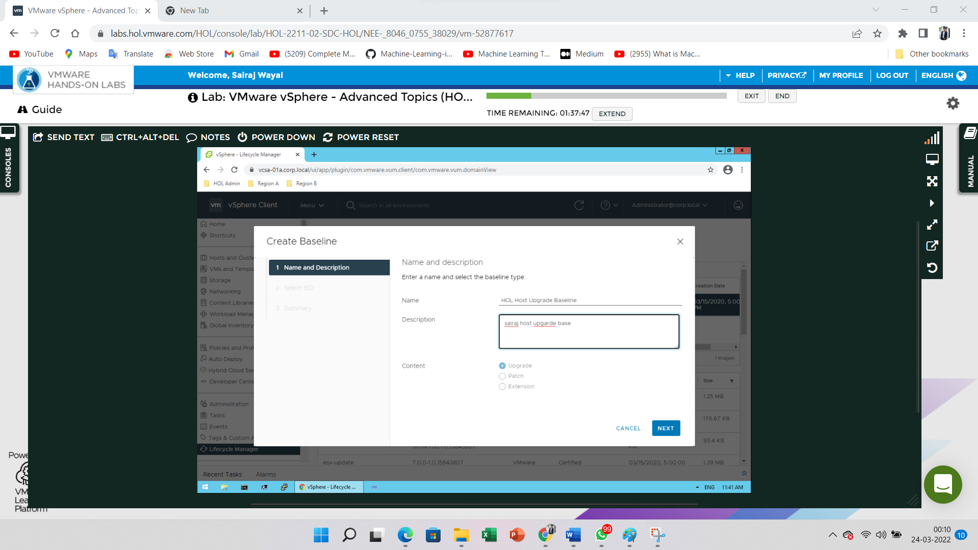

Select ISO file and click on the **Next** button

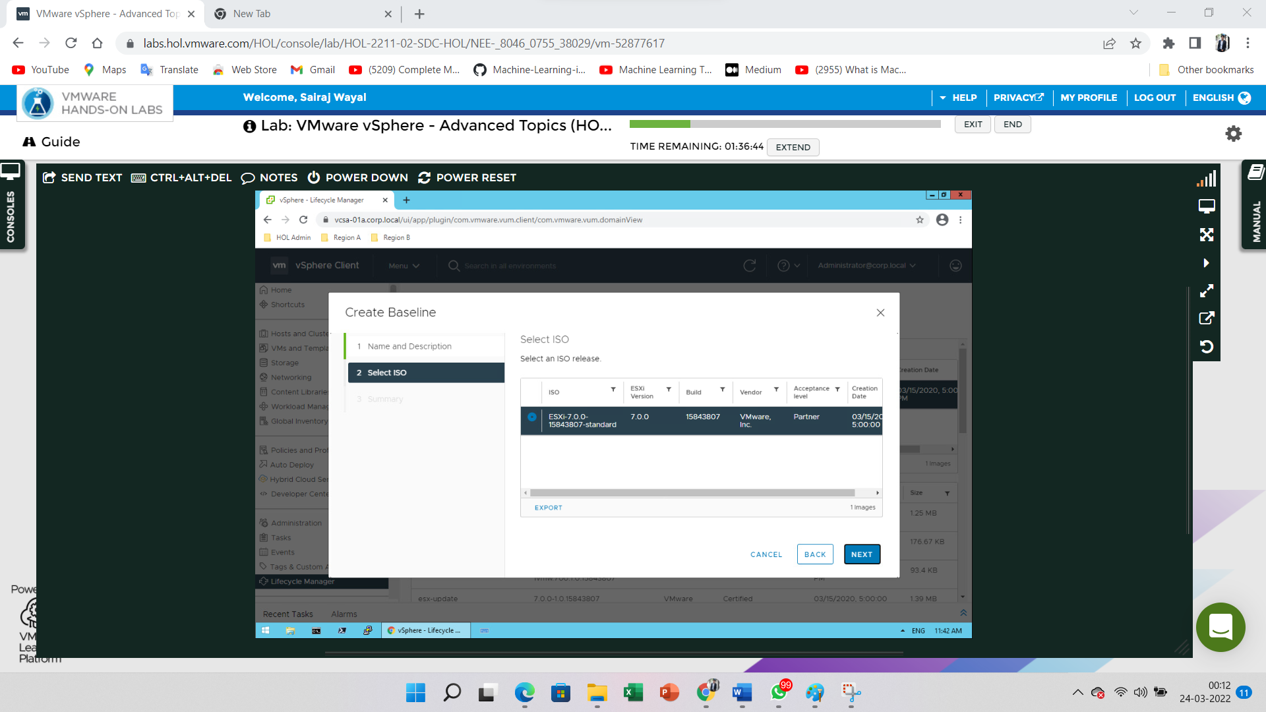

View the summery of Create baseline and Click on **Finish** button

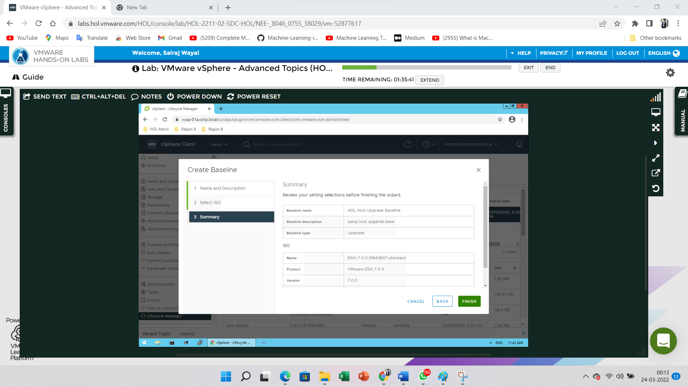

Tab on the **Baselines** tab and select the recently created Baseline option

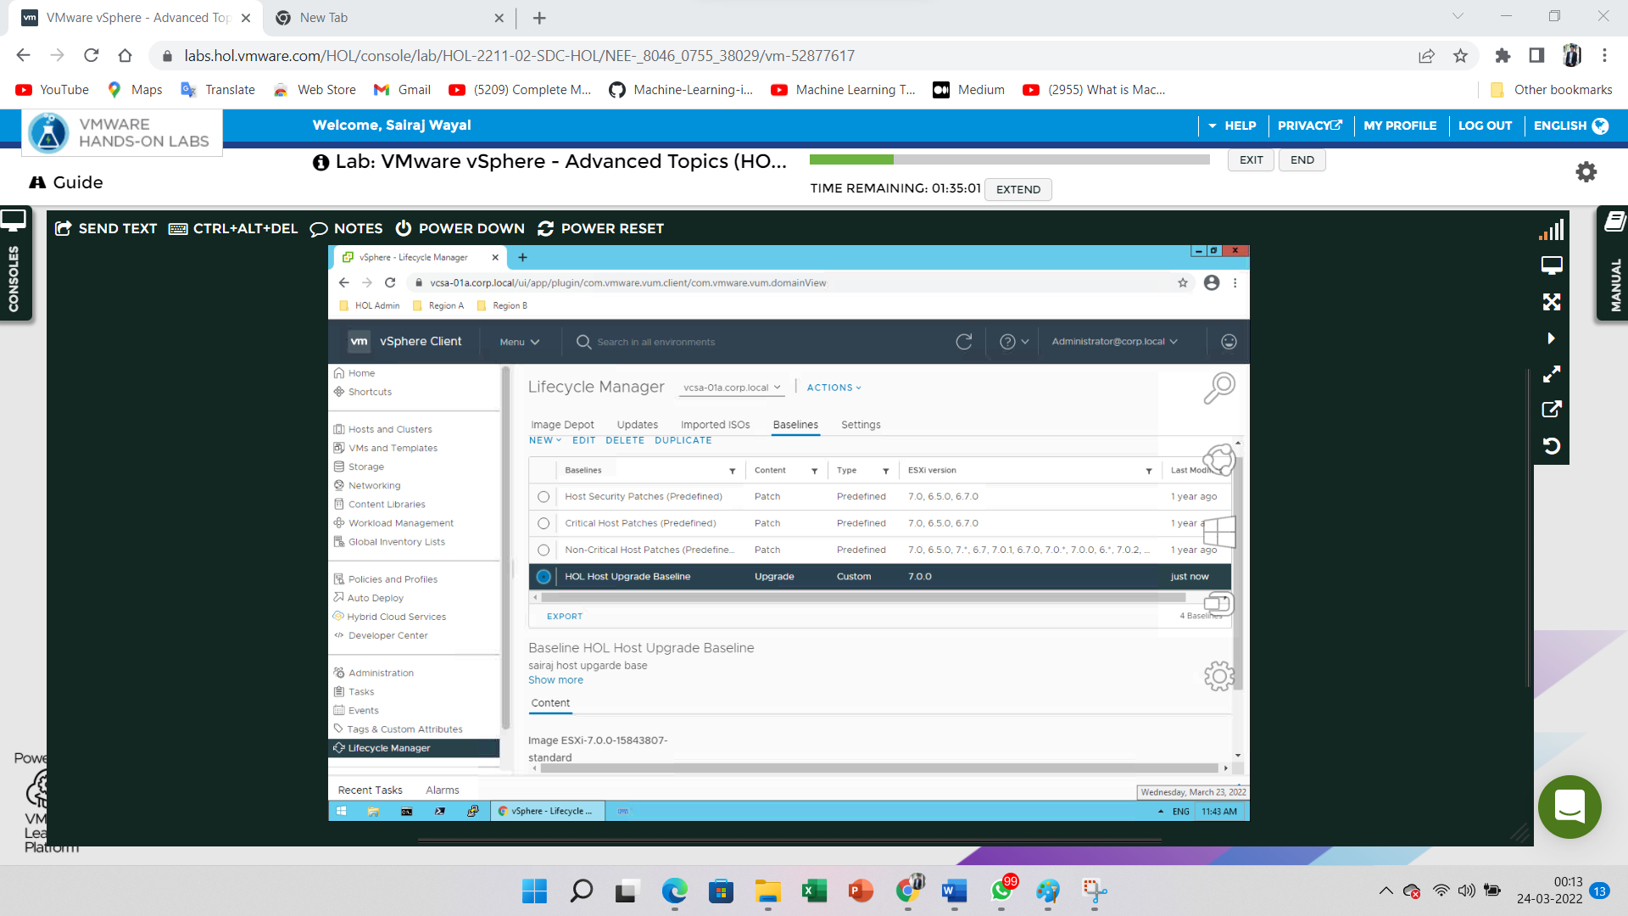

Go to the **Menu** and Click on the **Hosts and Clusters** option

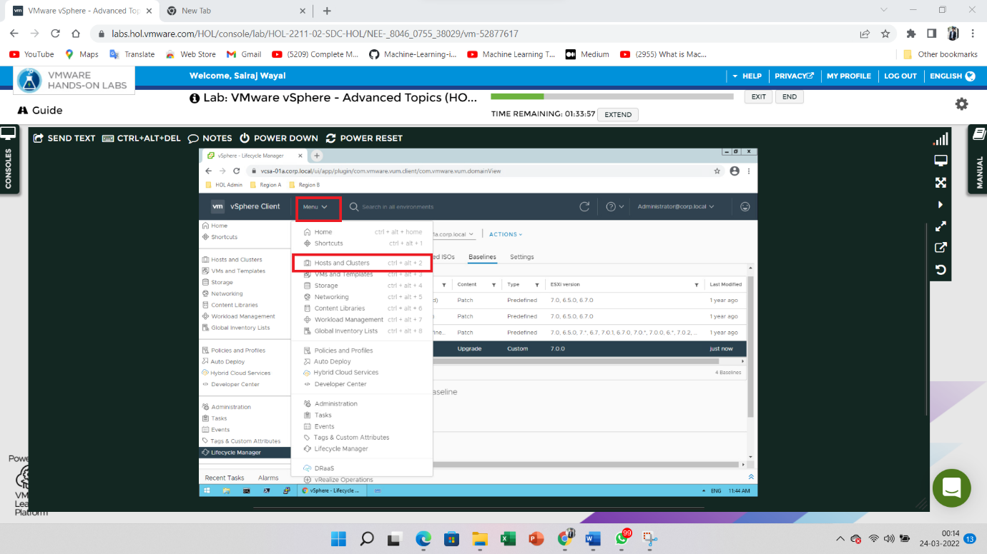

Go to the **RegionA01-COMP01** and Tab on the **Update** tab and Click on the **Baselines**

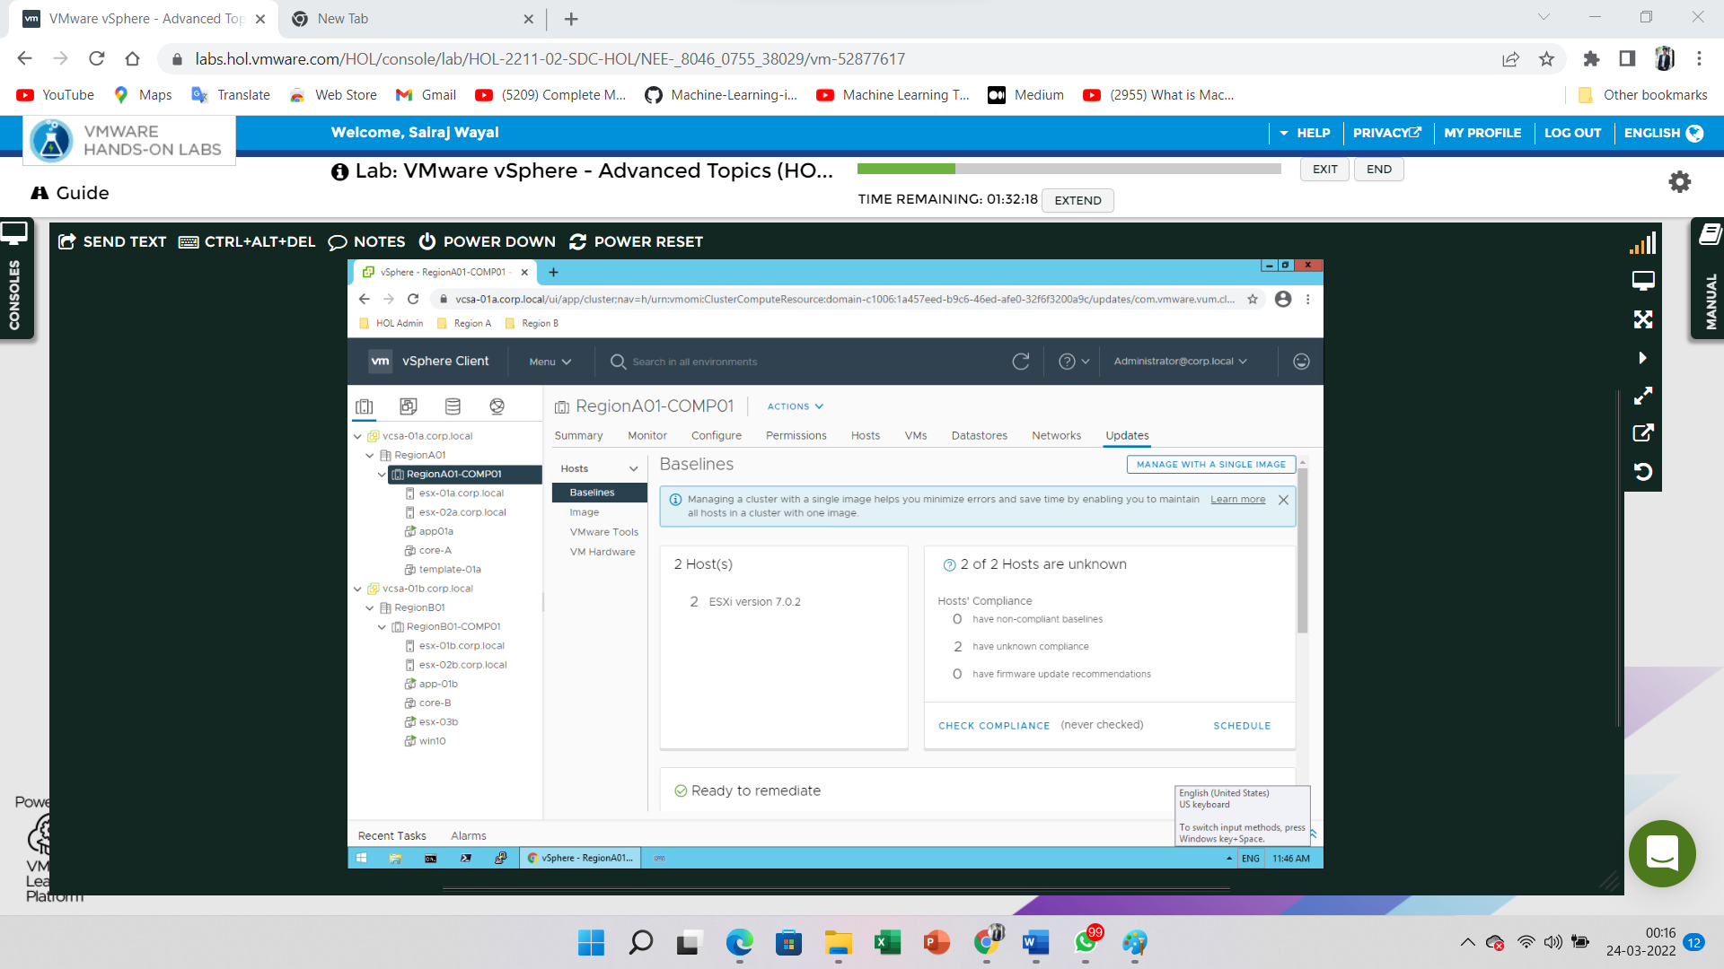

Scroll down the page. Select the **Attach Baselines or Baselines Group** on click an Attach button i.e. inside the Attached Baselines

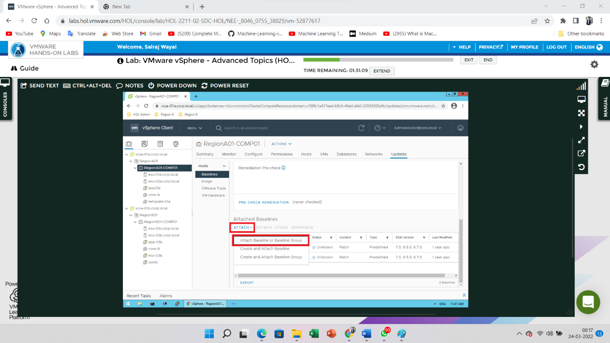

Check the Created Baseline inside the Attach | RegionA01-COMPO1 and Click on **Attach** button

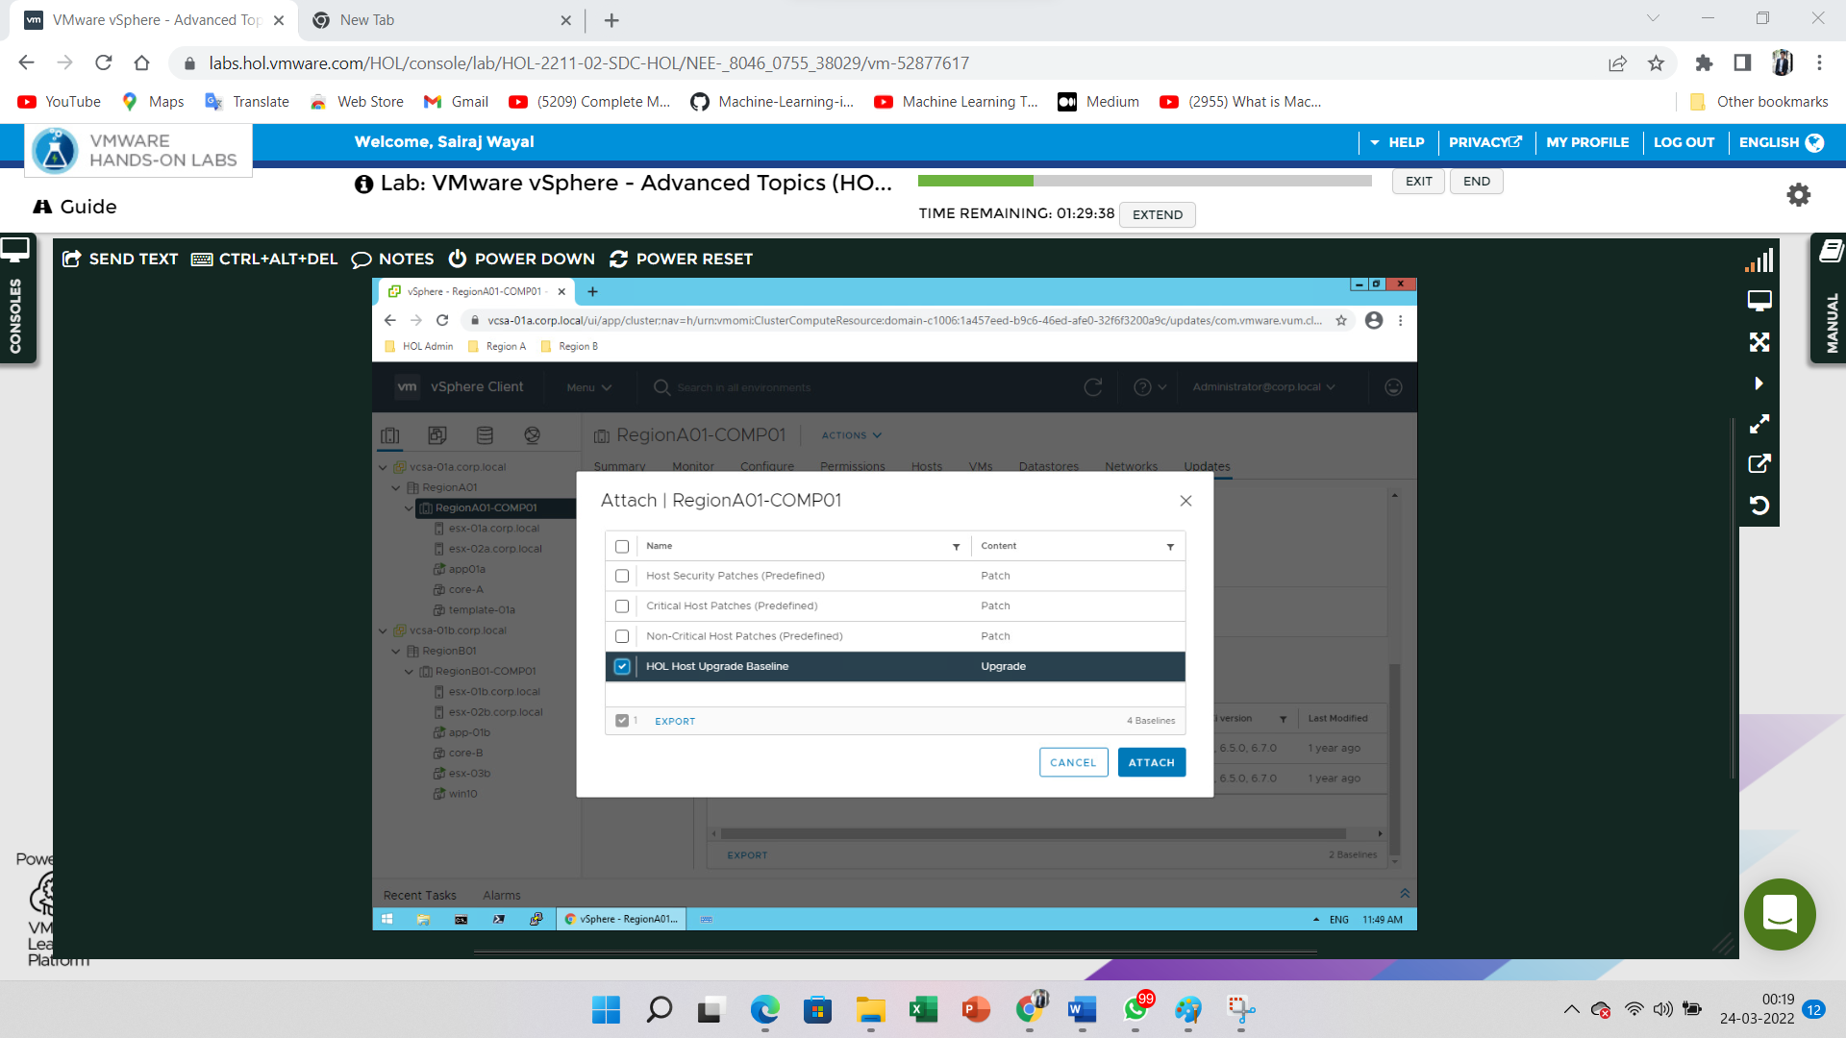

View the Attach Baseline inside the Attached Baseline section

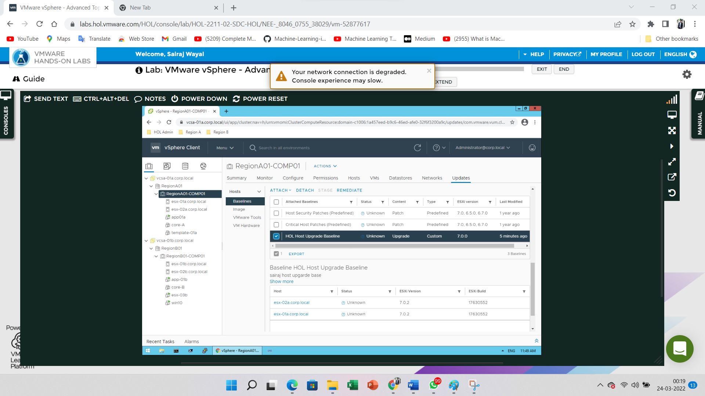

Scroll up Click on the Check Compliance inside the Baseline section

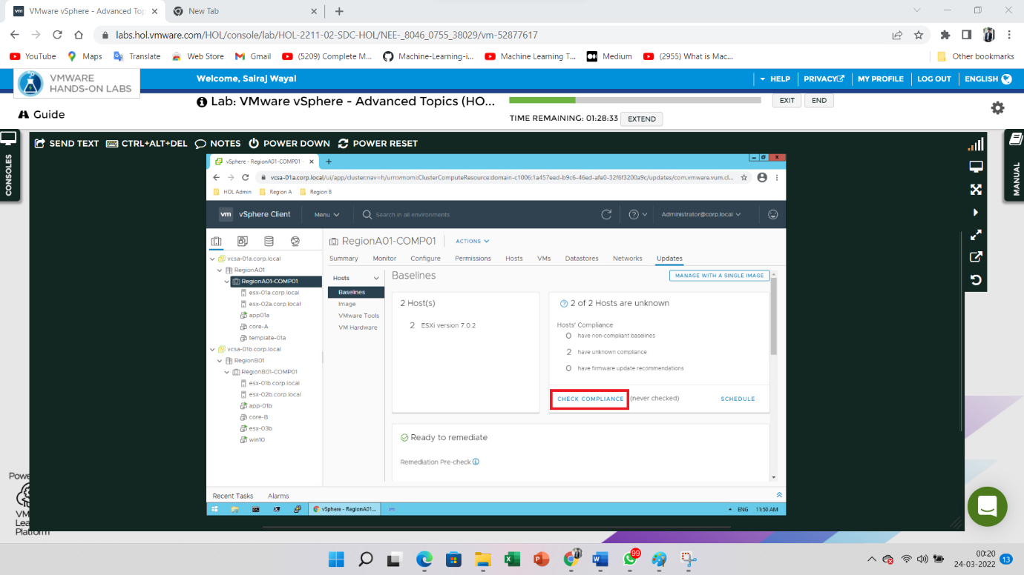

In Recent Task show the progress of recent activity

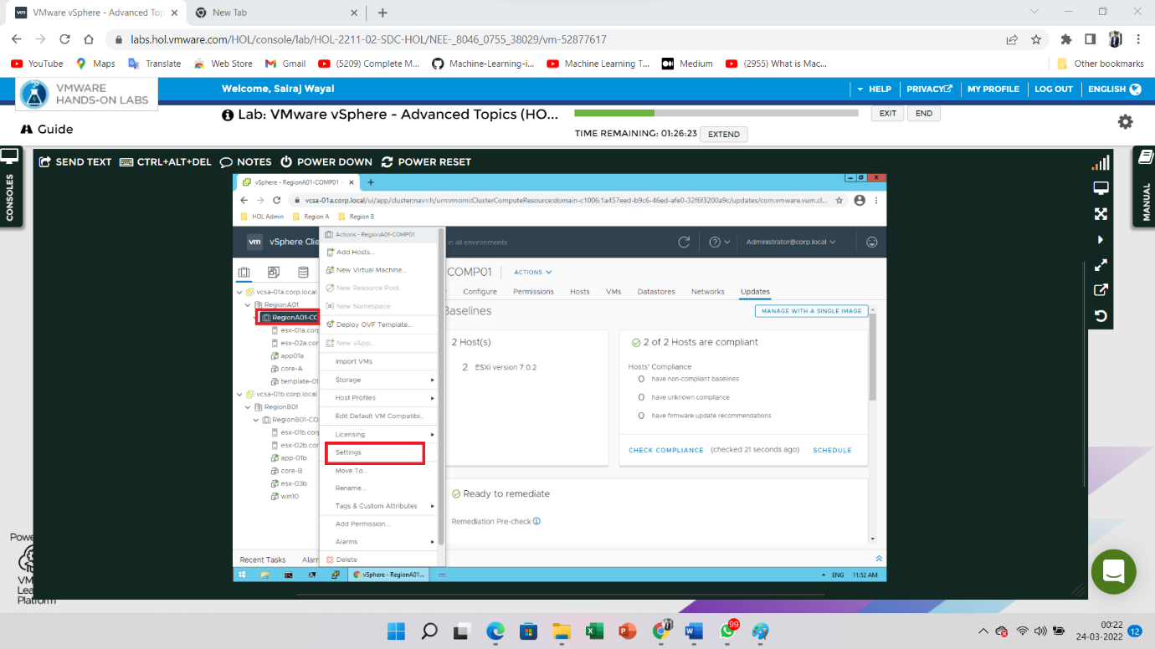

Go to the **Configure** Tab and Click on the **vSphere DRS** option. Inside the vSphere DRS option have **Edit** button click on the button

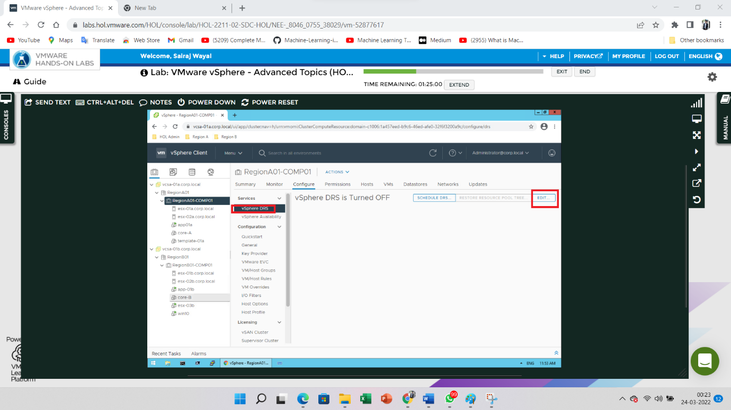

**Enable** the vSphere DRS on click on the toggle and Click **OK**

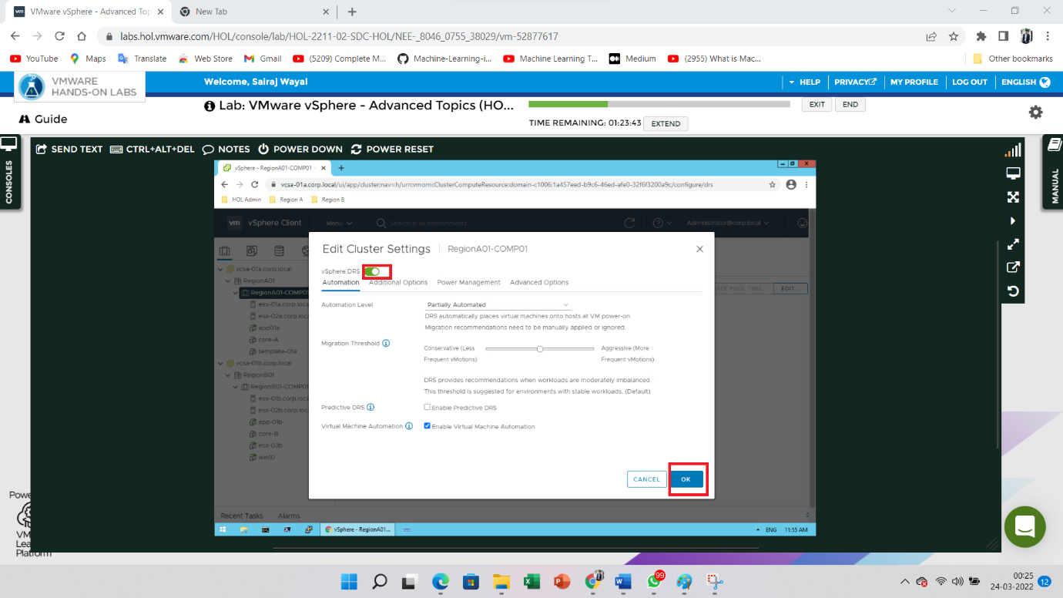

Now again go to the RegionA01-COMP01. Tab on the **Update** Tab and Click on the **Baselines** option. Inside the Ready to remediate section click on the **Pre-Check Remediation** button

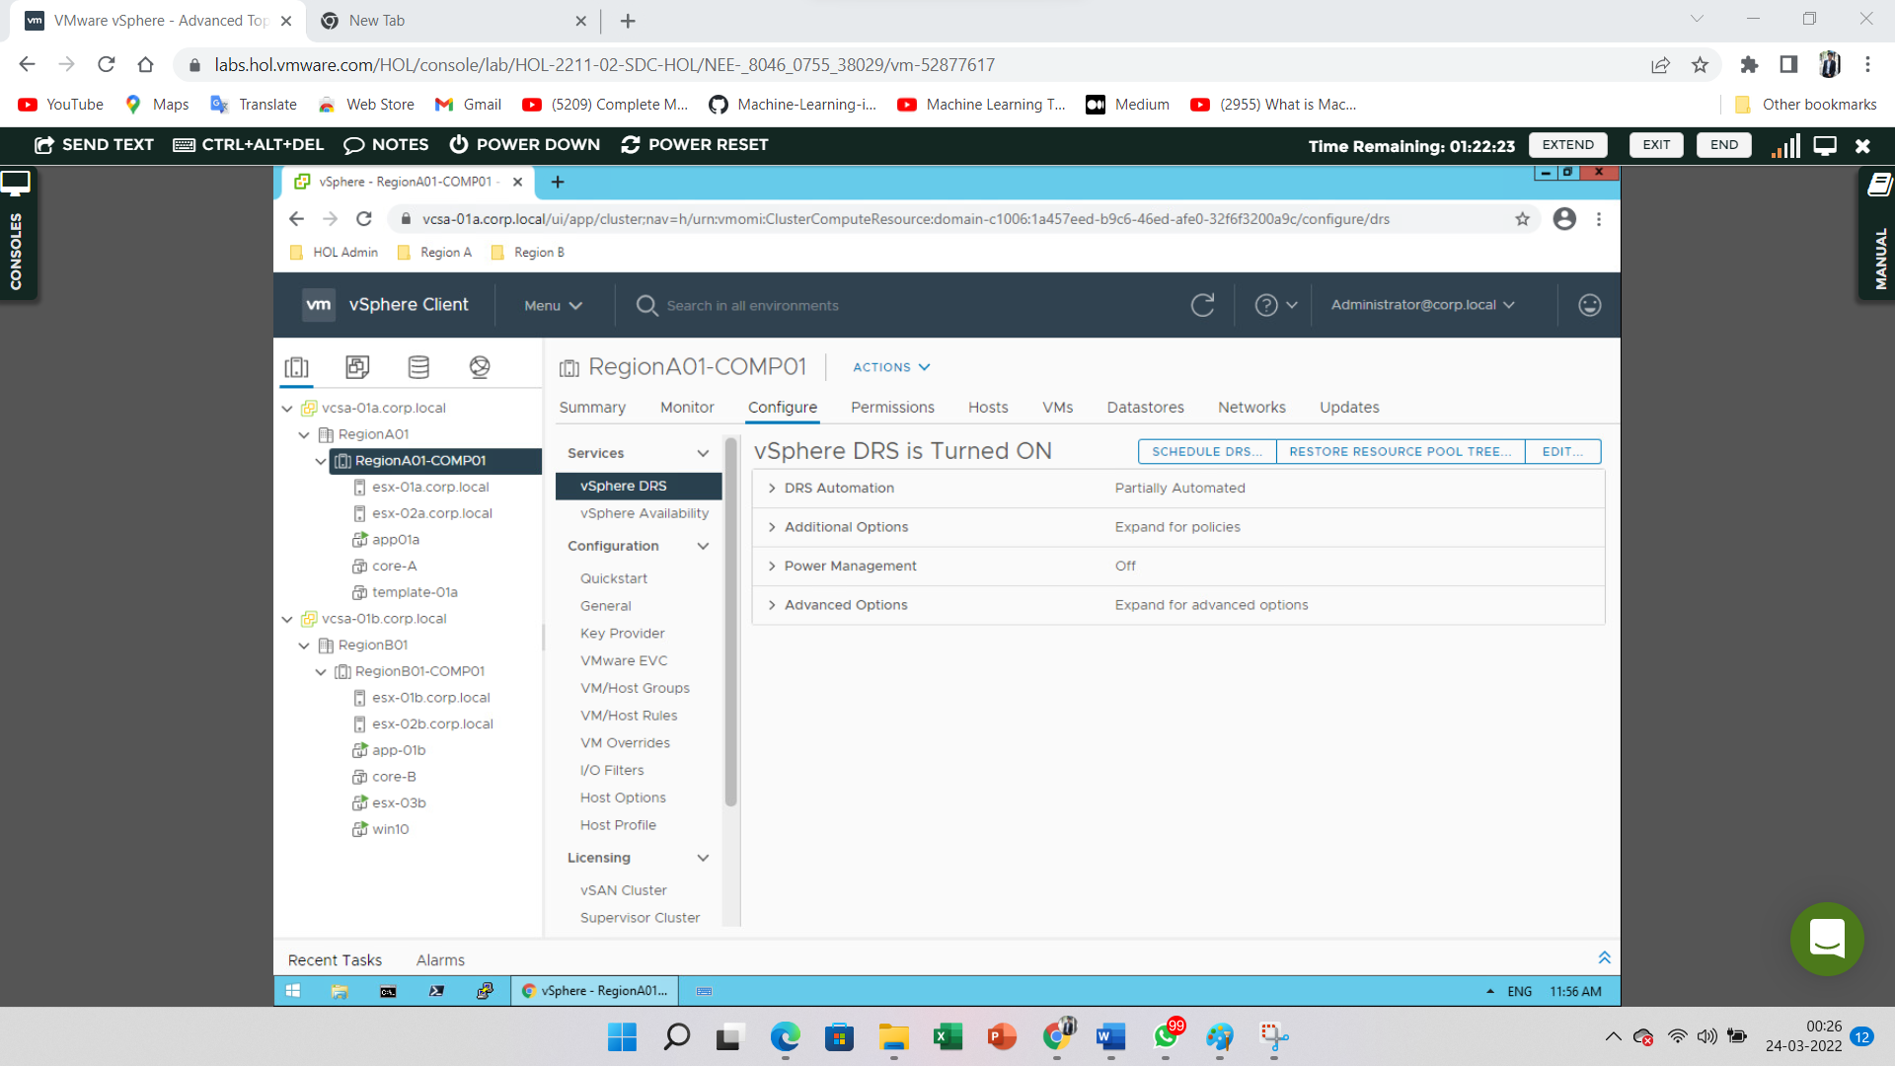

First click on the **Re-Run Pre-Check** button and after that click on the **Done** button

